A donation has been made in your honor
to the New Community Project
NCP is a small nonprofit organization with a Big Goal: to change the world!
Toward this end, NCP plants trees and protects forests, educates girls and empowers women, supports native communities, and challenges all of us to live respectfully and responsibly with earth and its people.

Gift: _____________________________________________________
Given in honor of: __________________________________________
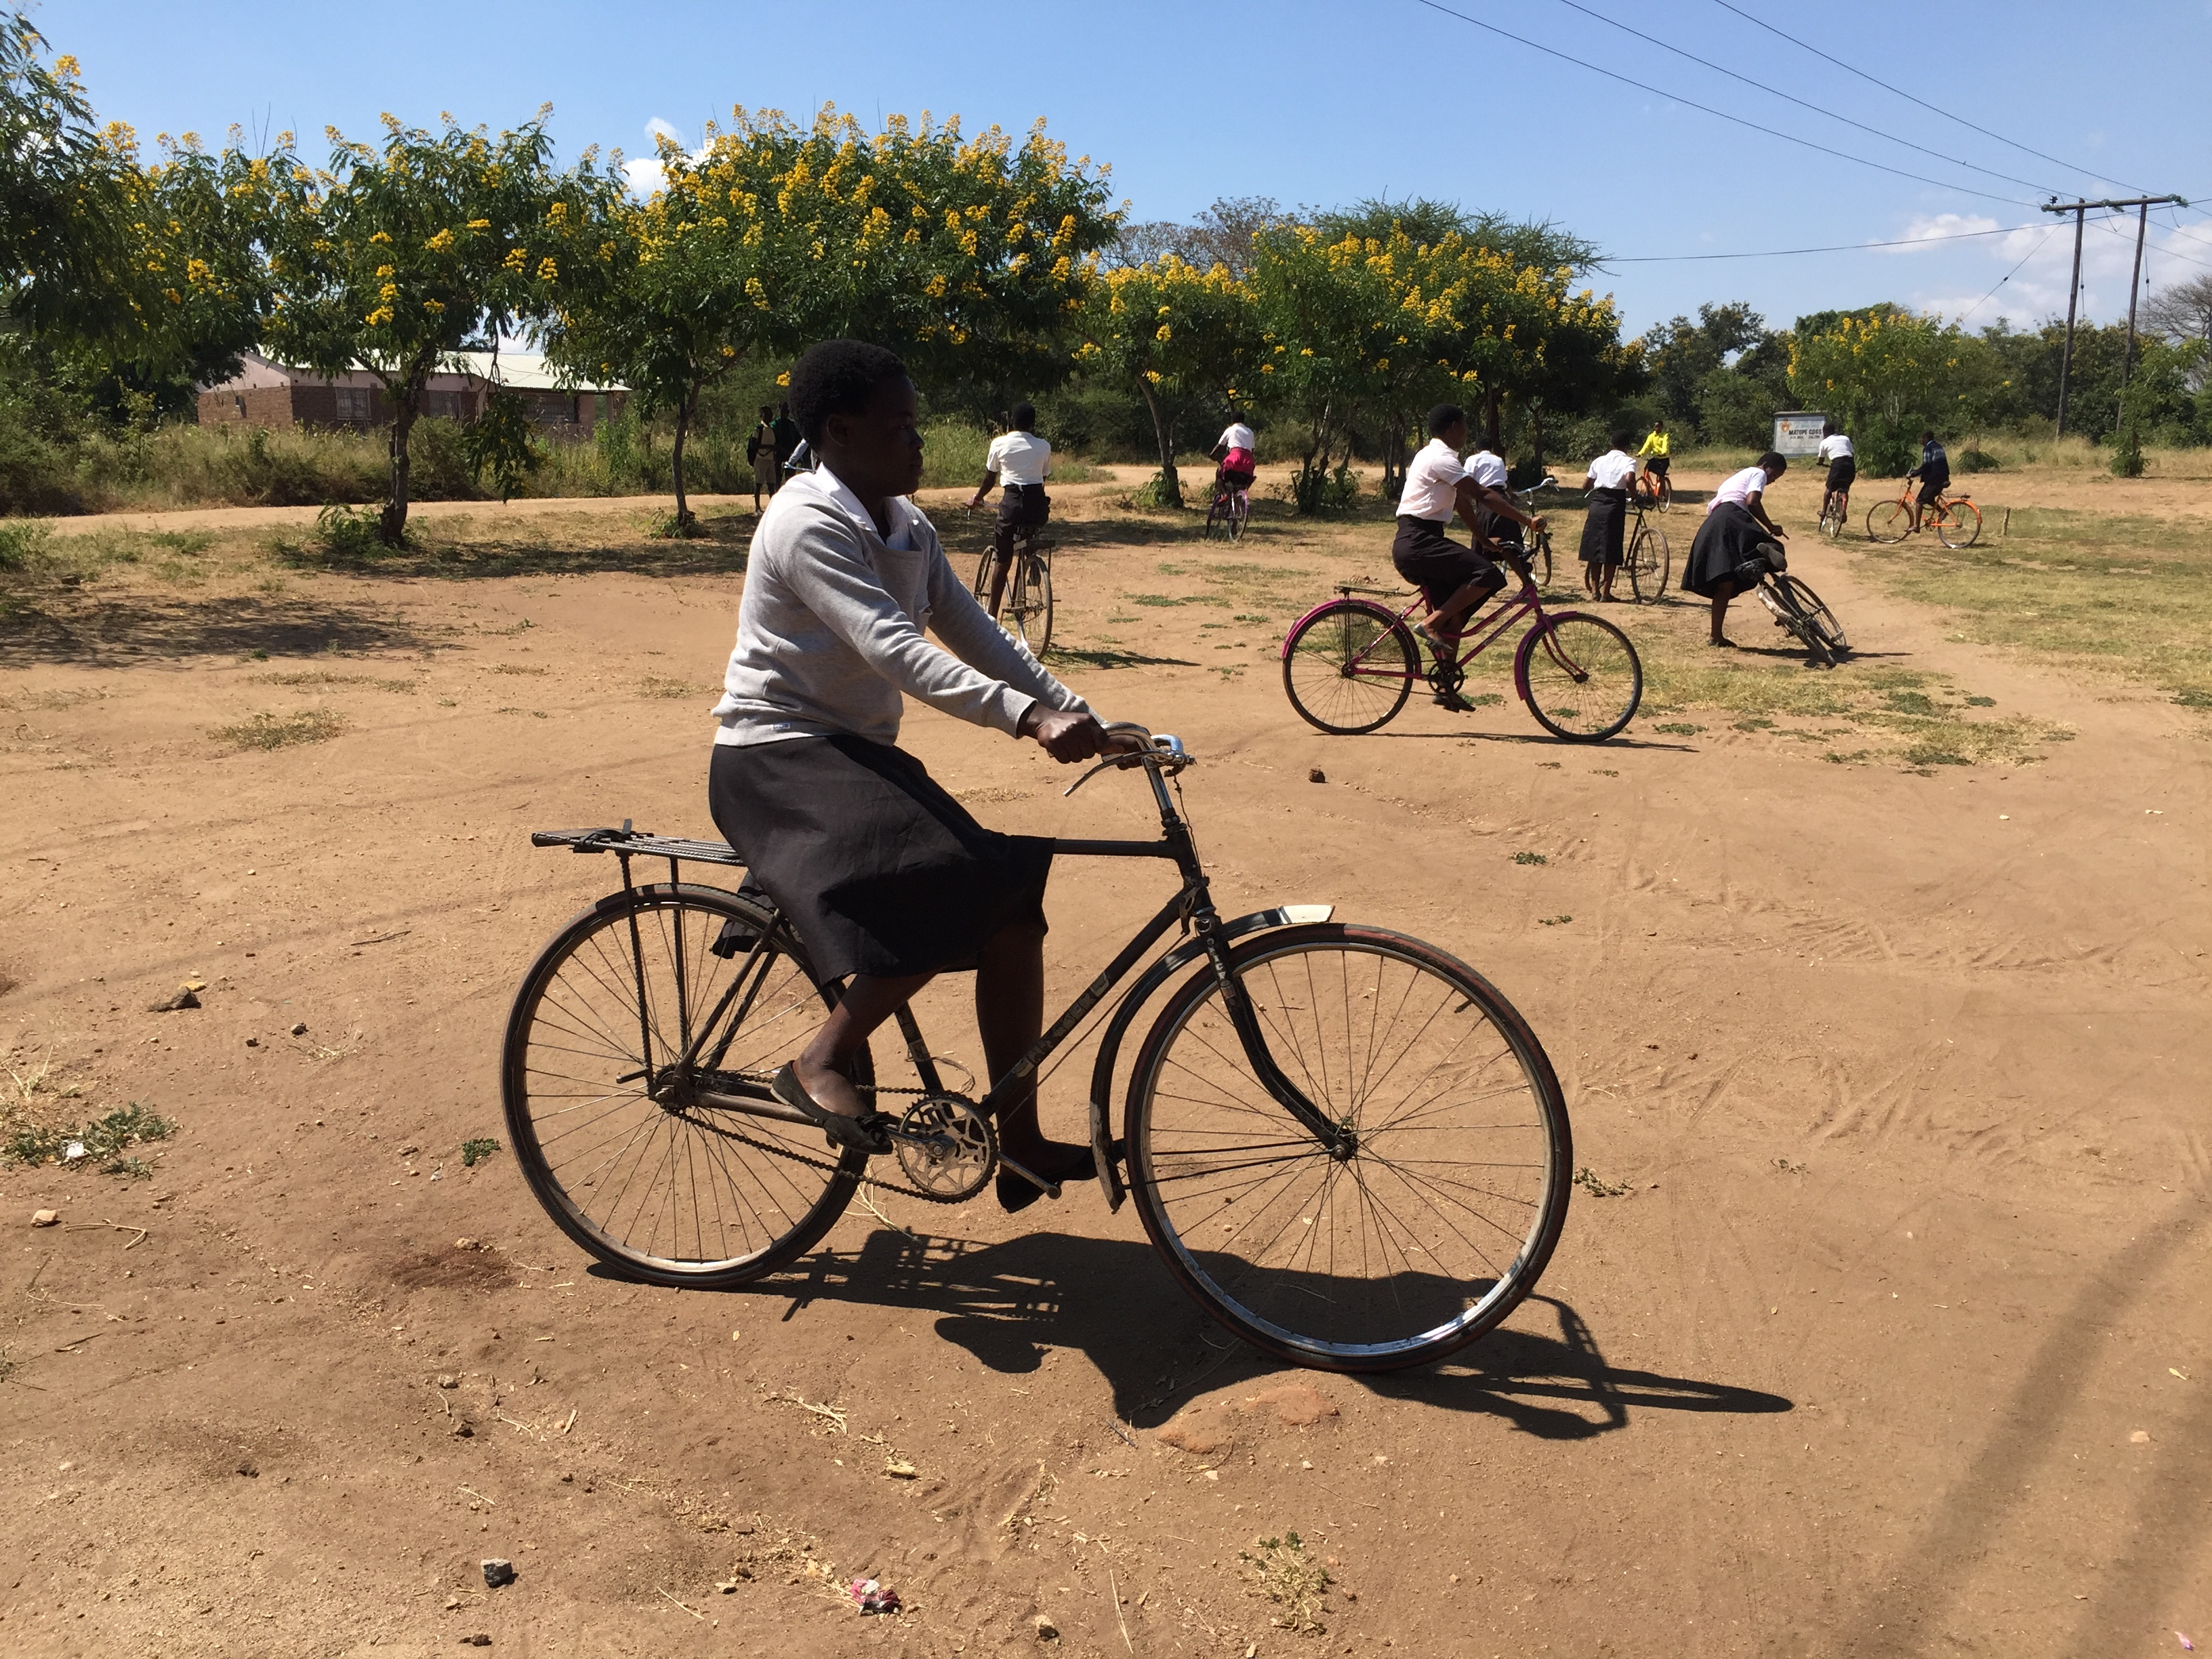
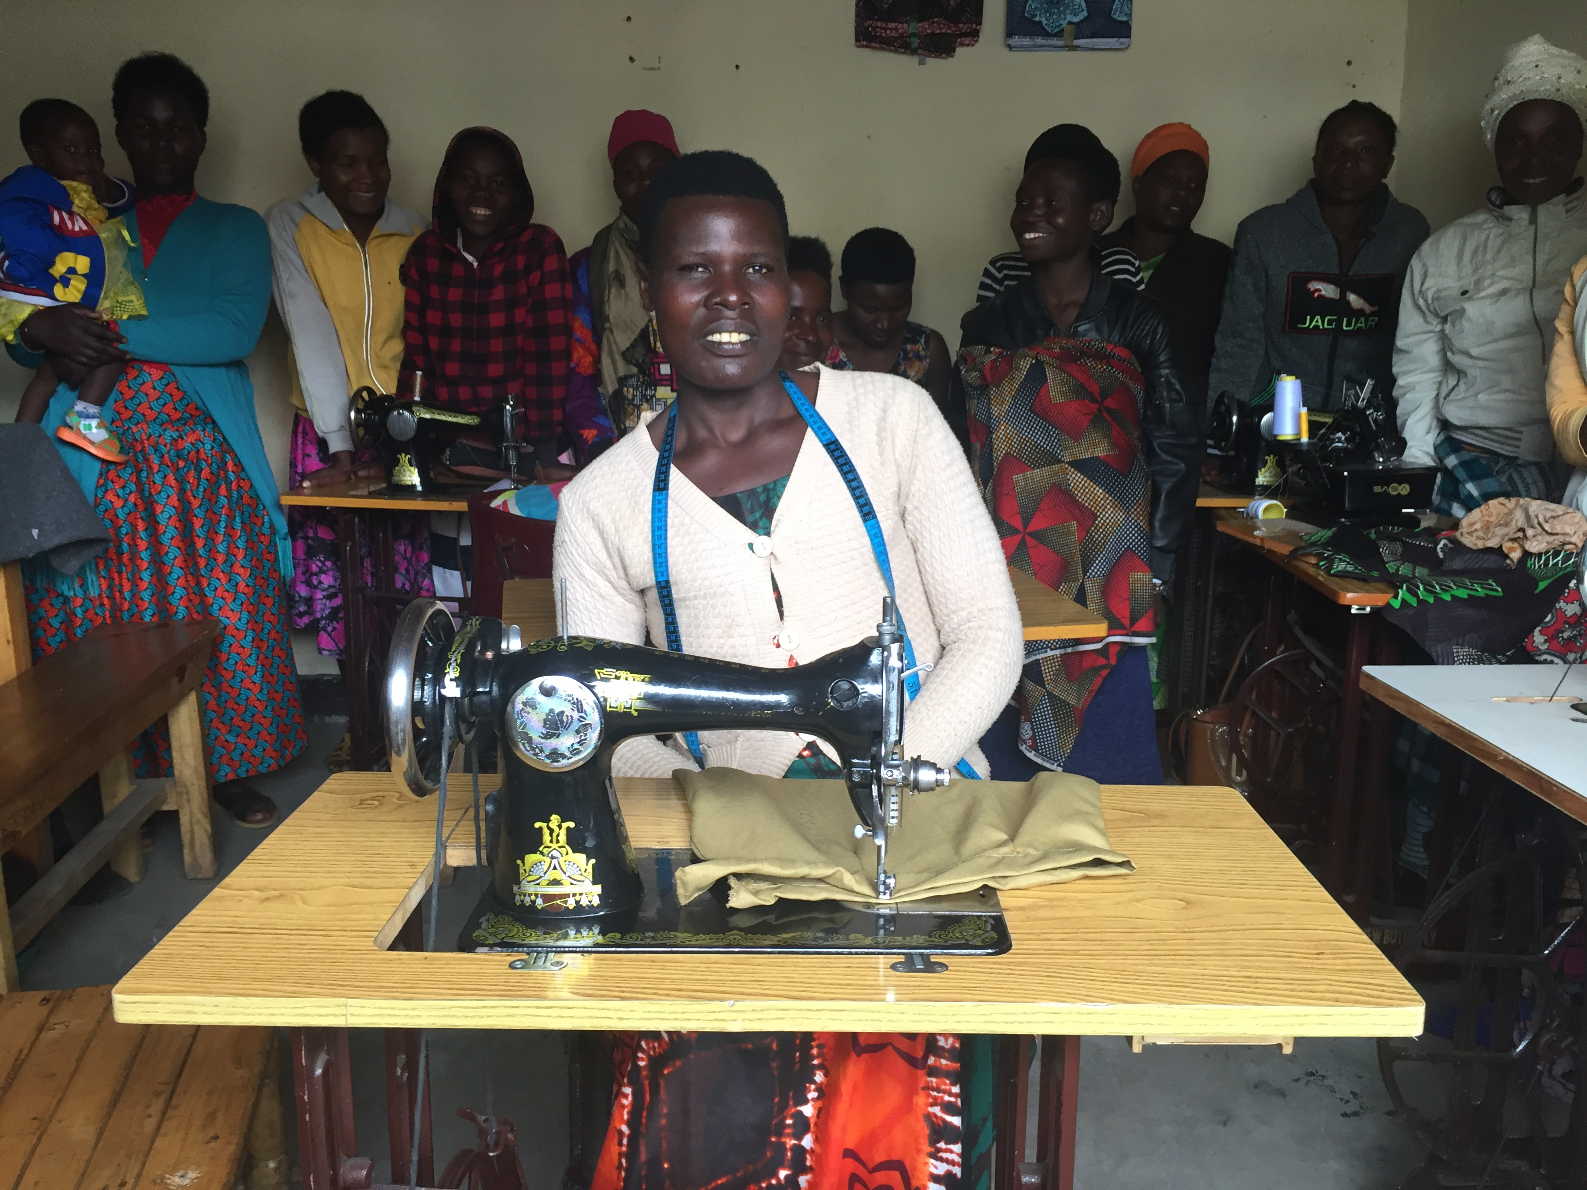
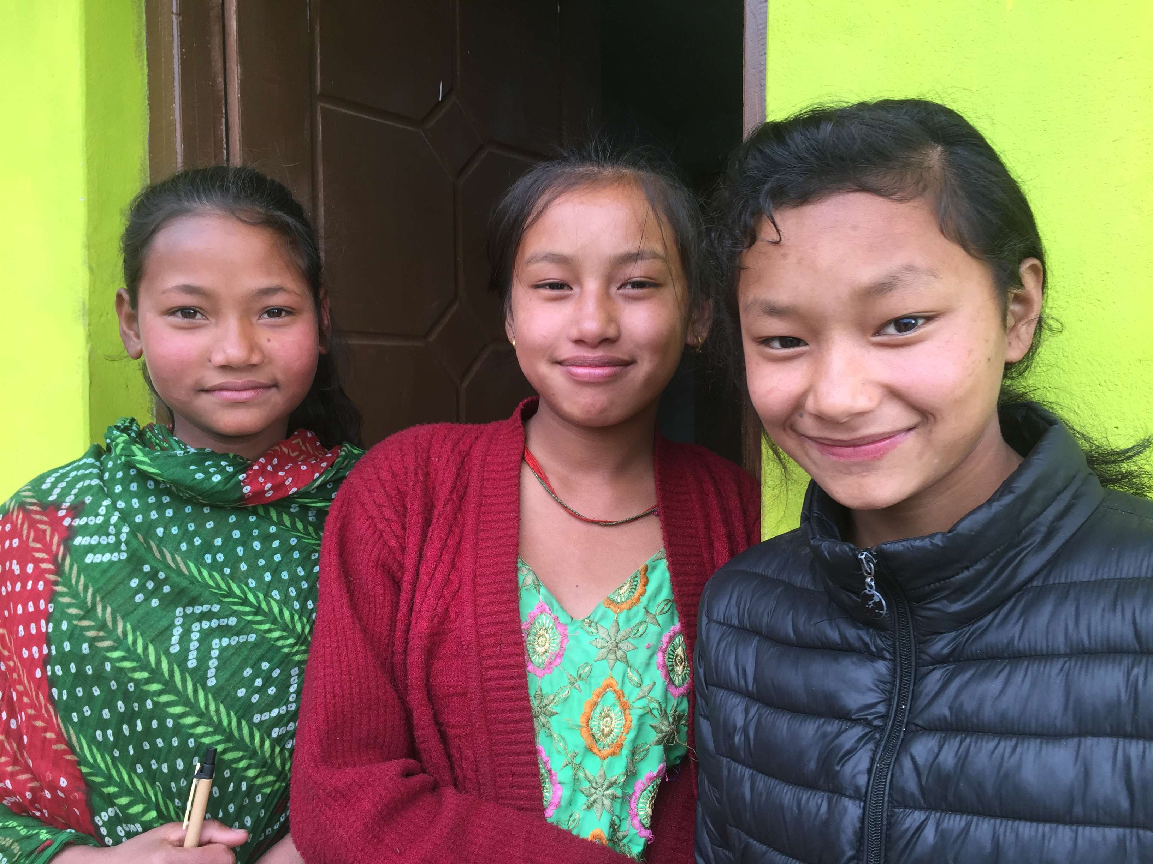
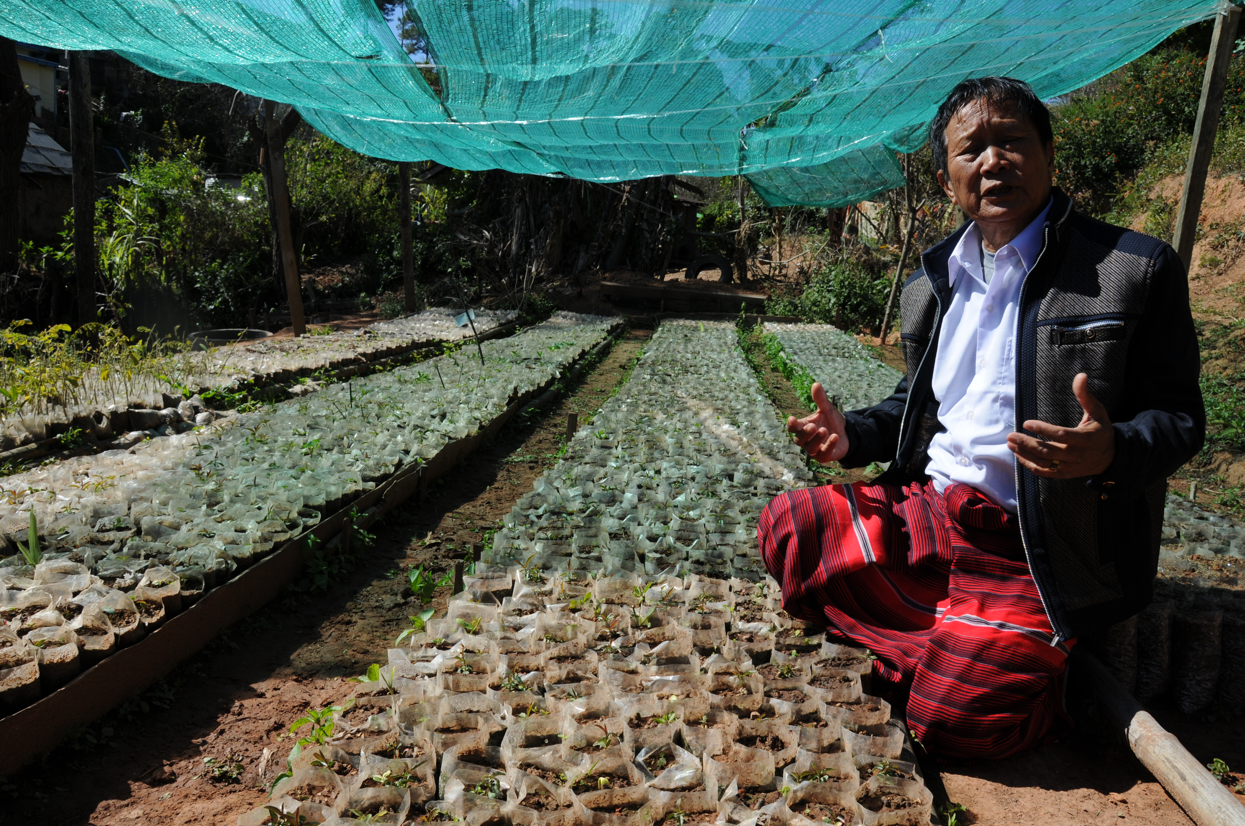
Gift given by: ______________________________________________

A donation has been made in your honor
to the New Community Project
NCP is a small nonprofit organization with a Big Goal: to change the world!
Toward this end, NCP plants trees and protects forests, educates girls and empowers women, supports native communities, and challenges all of us to live respectfully and responsibly with earth and its people.

Gift: _____________________________________________________
Given in honor of: __________________________________________
Gift given by: ______________________________________________

A donation has been made in your honor
to the New Community Project
NCP is a small nonprofit organization with a Big Goal: to change the world!
Toward this end, NCP plants trees and protects forests, educates girls and empowers women, supports native communities, and challenges all of us to live respectfully and responsibly with earth and its people.

Gift: _____________________________________________________
Given in honor of: __________________________________________
Gift given by: ______________________________________________

A donation has been made in your honor
to the New Community Project
NCP is a small nonprofit organization with a Big Goal: to change the world!
Toward this end, NCP plants trees and protects forests, educates girls and empowers women, supports native communities, and challenges all of us to live respectfully and responsibly with earth and its people.

Gift: _____________________________________________________
Given in honor of: __________________________________________
Gift given by: ______________________________________________

