Thank you for honoring New Community Project as the recipient of this special offering! As seems fitting, we will divide your gifts in a trinitarian fashion between Creator (our care for creation programs), son (our work of transformation), and Spirit (our work with women and girls around the world).
Educating girls and empowering women is one of the most important things we do at NCP. It enables them to develop the skills that God has given them while also enhancing their sense of self-esteem. There is also a huge benefit to their communities as they can play a more active role politically, economically and otherwise, and to the environment, as they have fewer and healthier children.
On the 20th anniversary of NCP in 2023, we added up the number of girls that we have educated in these 20 years (7600), the number of women who have been trained as tailors, beauticians, stove makers, and midwives (10,500), and those who have been provided with micro loans to smart start small businesses (650).
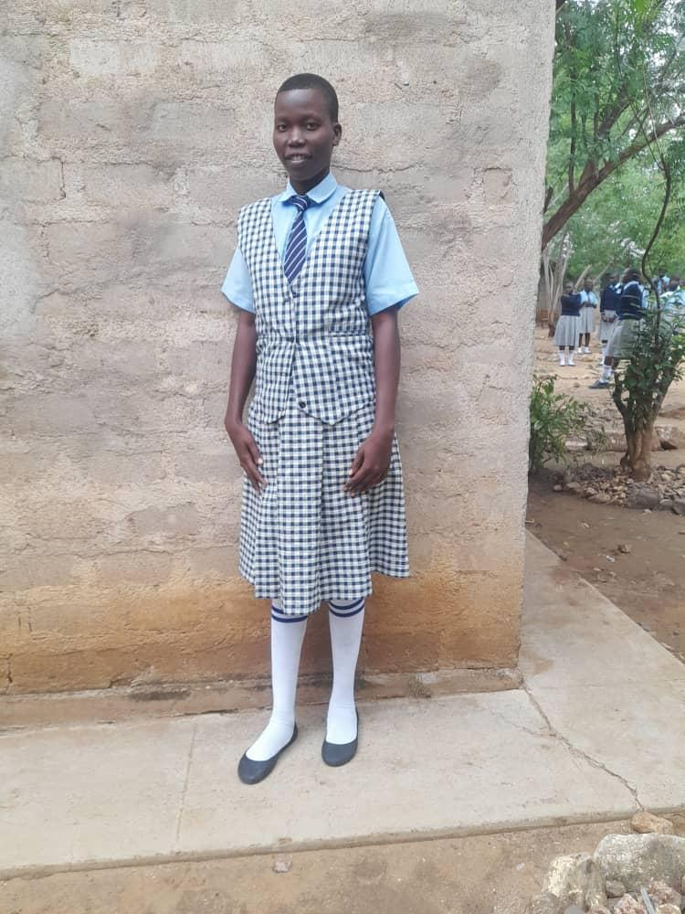
Josephine was a 10 year-old girl in South Sudan who realized that she would likely share the fate of her elder sister in being married off to an older man. Her father had died and her uncle was now in charge of the family, and he was very interested in gaining wealth from marrying off his nieces. So Josephine decided to join other girls in running away from home. They headed for Blessed Bakhita girls school in Narus, walking six days with no food or water to get there. On arrival, they were welcomed by the head teacher and received a scholarship from NCP's Give a Girl a Chance fund. She remains there to this day, where she says she has learned to speak English, has gained skills training and become a footballer. In the future, she wants to work in the Ministry of Education in order to help girls avoid early marriage and get the education they need for a better future.

The second part of our trinitarian formulation is care for God’s creation. I could hardly believe my eyes when I tallied up the numbers from our partners in Africa Asia and South America – we’ve been responsible for planting 3,700,000 trees over the past 20 years. Cumulatively, this pulls over 91,000 tons of carbon dioxide out of the atmosphere every year. And of course trees also provide habitat, medicines, fruit, soil retention, and shade. Few things are more important in our rapidly warming world then helping forests recover. Plus they are calming (and reduce crime rates) and just beautiful.
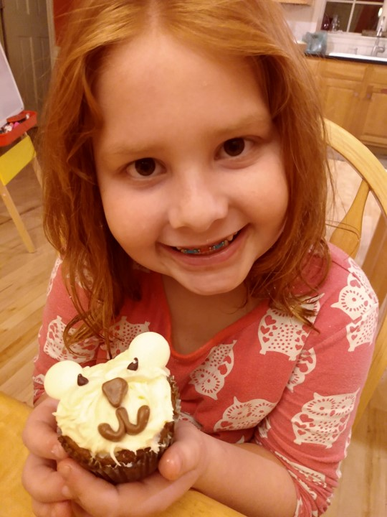
We also constantly remind people in our network about the environmental and spiritual impacts of our overconsumption, as it is ruining our earth and leading us to think that our life consists of our stuff. It doesn’t. And we hope to inspire people like Danielle to action. (Photo: bake sale for the polar bears to benefit NCP). Thank you for helping us do these good things for God’s earth – and our own and the polar bears’ future.

The final step of our three-part harmony is the portion of your special offerings that will go to our core programs here in the United States. We feel like the way to change people is via encounter with the world around us, not unlike the methodology of our Lord. So we invite people on our Learning Tours to see the world – both planet and people – up close and personal, having an encounter there that puts us in a place to see this world and ourselves differently, and where God may be calling us in that process. We also have the Sustainable Living Centers where people visit to listen and learn or to help out in tangible ways as we grow food in eco-friendly ways, restore streams, promote bicycles and energy efficiency, and reach out to the marginalized. And our staff travel far and wide speaking to schools, colleges, and congregations. All told, we have had over 27,000 visitors to our sites and made over 2000 visits to schools, churches, and community gatherings.
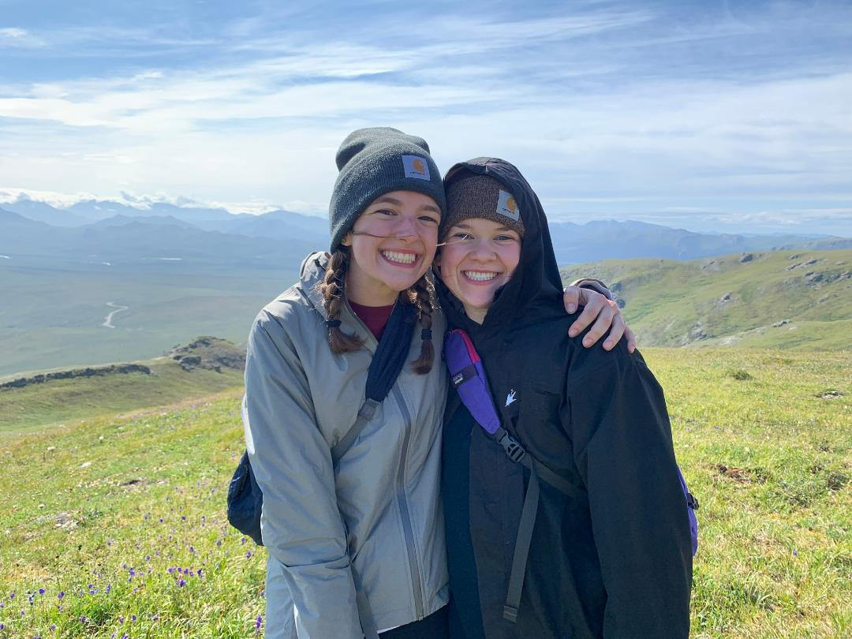
18 year-old Anna (at left in photo) from southwest Virginia went with us to Denali in 2021. She said later that seeing the experience, and especially seeing the impacts of climate change up-close-and-personal, changed her life. Coming home, she changed her major to green engineering, and then spent most of the next summer as an intern at our Sustainable Living Centers in Virginia and Vermont.
So that’s what we try to do in our core programs – give people the opportunity to see themselves and the world differently and then to figure out where that may take them. Thank you for helping us do these things here, there and everywhere.

